Secure Cloud Storage & Backup Management System
- Denzil Abraham R(727723eucy015)
Platform: Amazon Web Services (AWS)
Role: Cloud Administration Intern

1. Project Objective
The objective of this project is to design and simulate a secure, reliable cloud-based storage and backup solution using AWS. The solution ensures data availability, access control, backup, and recovery from failures.

2. AWS Services Used
- Amazon S3 (Object Storage with Versioning)
- Amazon EC2
- Amazon EBS (Block Storage)
- Amazon EBS Snapshots
- AWS IAM (Access Control)
- AWS Encryption (SSE-S3 / KMS – Conceptual)

3. Step-by-Step Implementation with Screenshot Instructions

Step 1: Create S3 Bucket
Action:
• Go to AWS Console → S3 → Create Bucket
• Enter bucket name and region
• Enable Versioning
• Block all public access
Screenshot: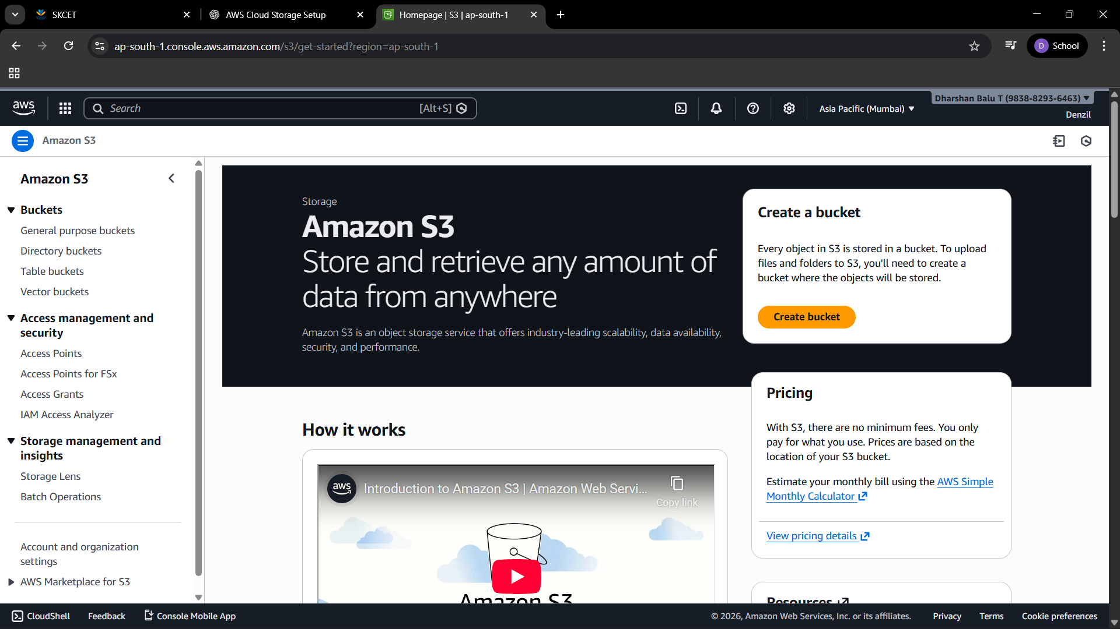
• S3 Create Bucket screen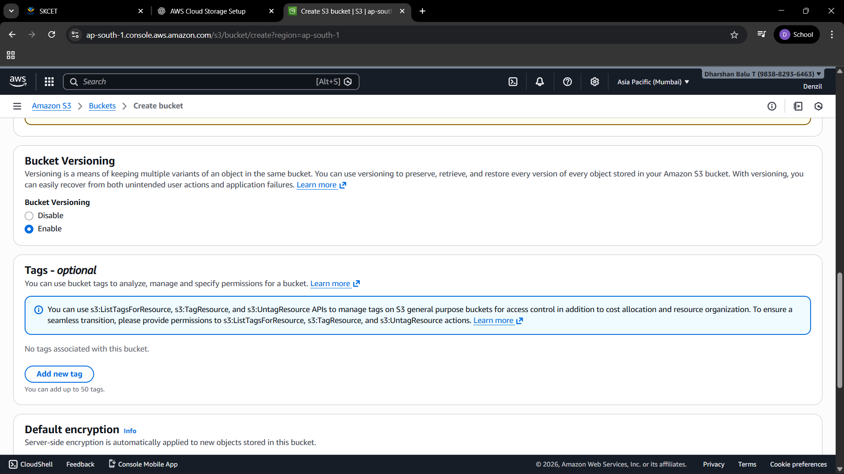
• Bucket properties showing Versioning enabled

Step 2: Upload Business Files
Action:
• Open the bucket → Upload files
• Upload sample business documents
Screenshot:
• Upload screen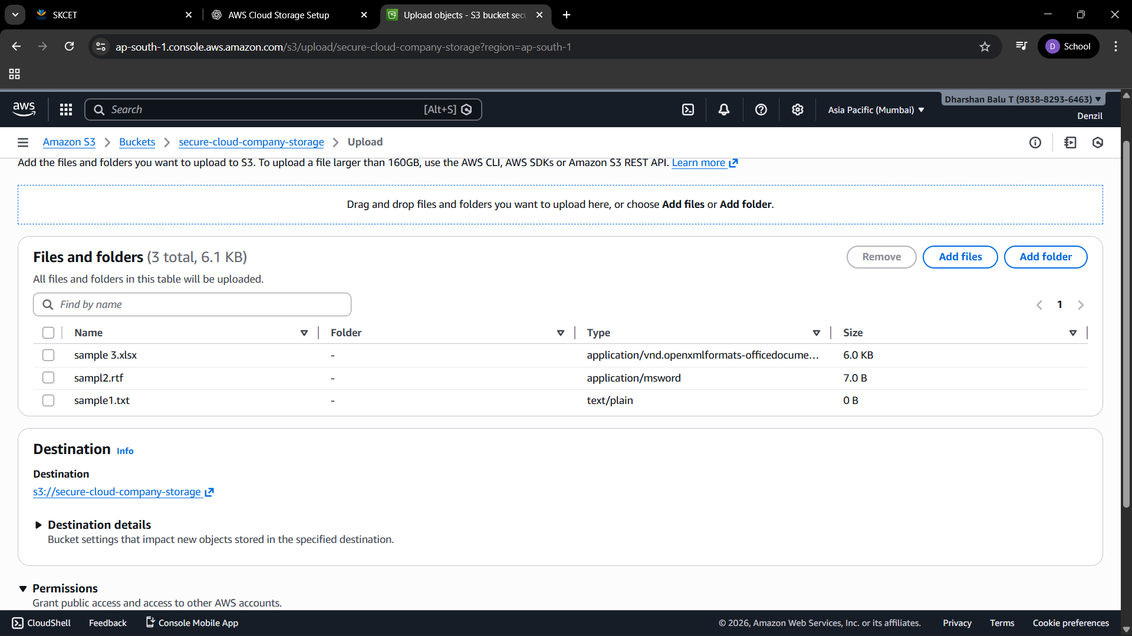
• Files visible inside bucket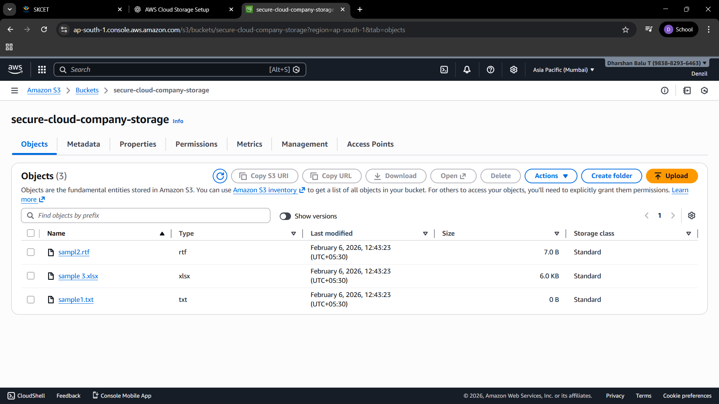

Step 3: Enable S3 Encryption
Action:
• Go to Bucket → Properties → Default Encryption
• Enable SSE-S3 encryption
Screenshot: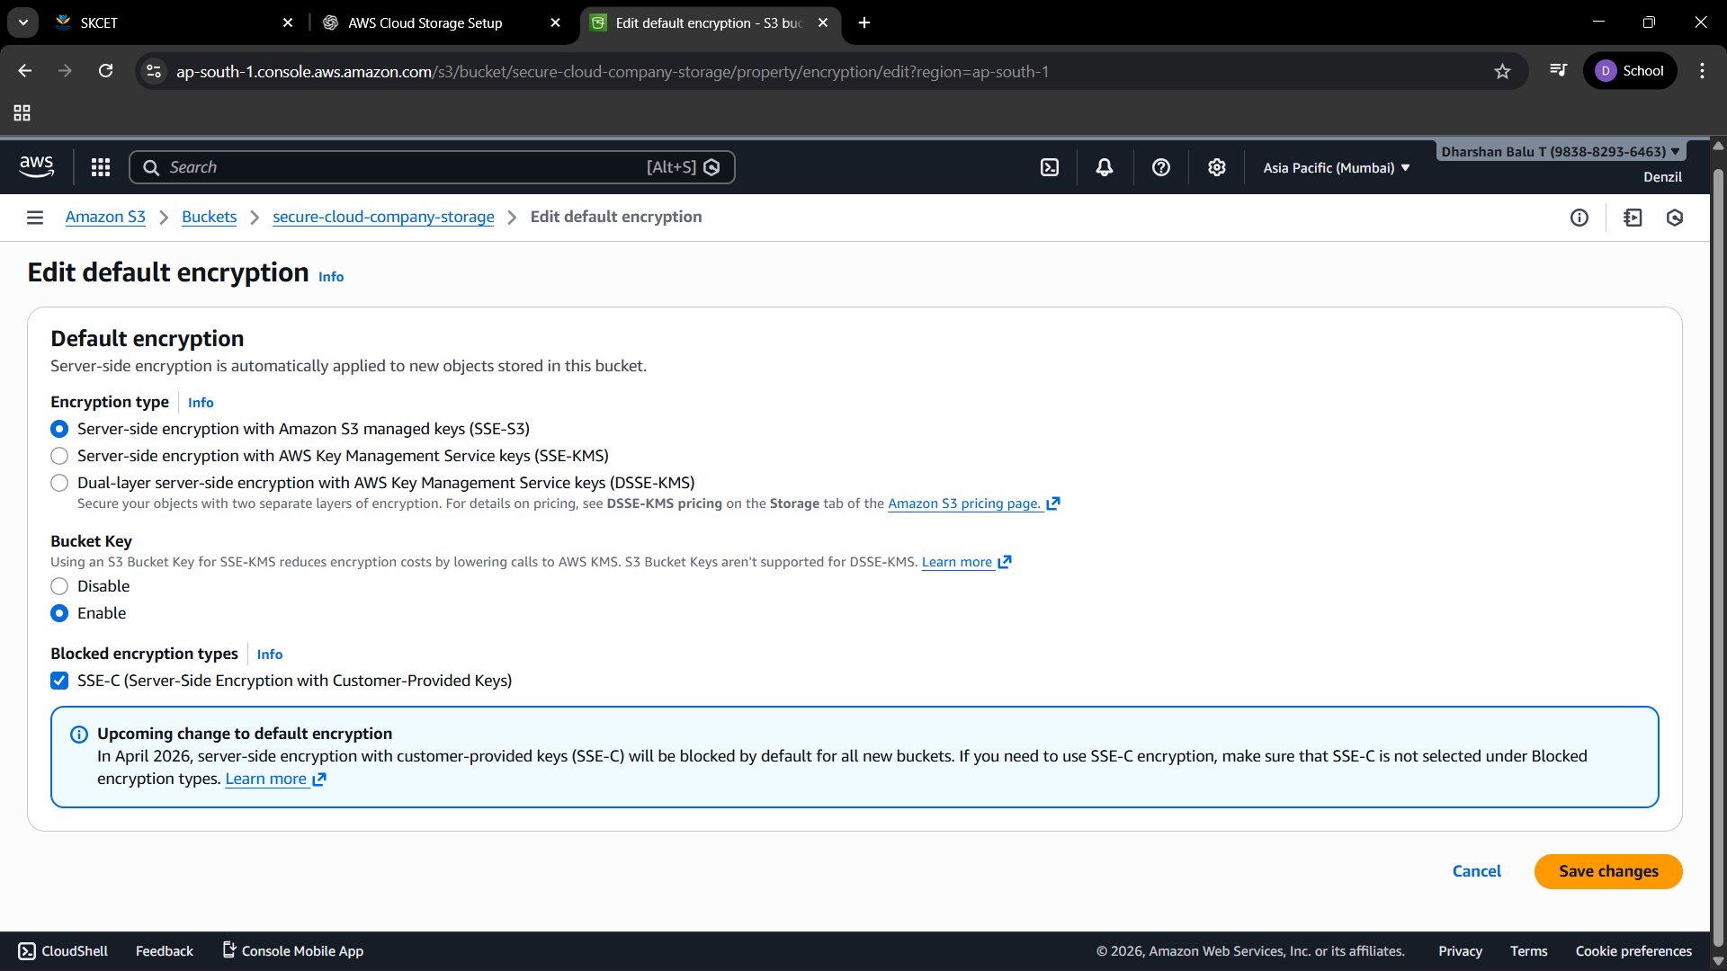
• Encryption enabled section

Step 4: Create IAM Users
Action:
• Create Admin user with AdministratorAccess
• Create User with AmazonS3ReadOnlyAccess

Screenshot:
• IAM users list
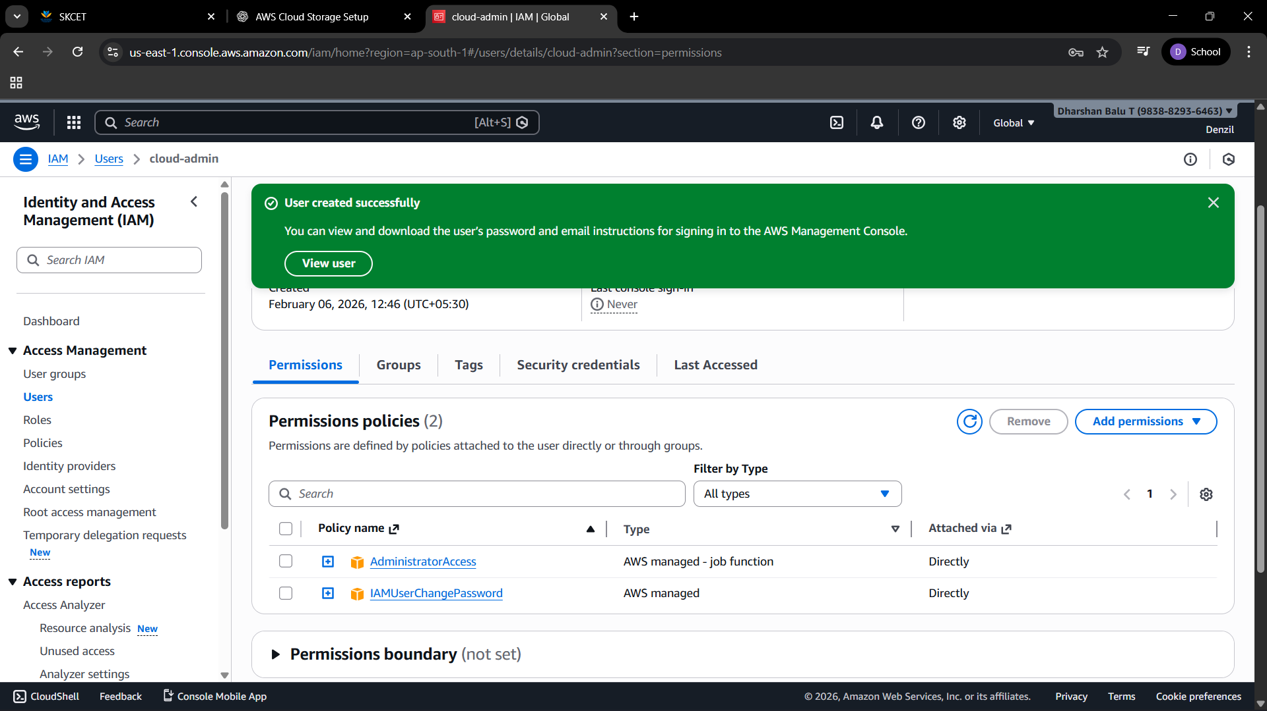
• Attached policies
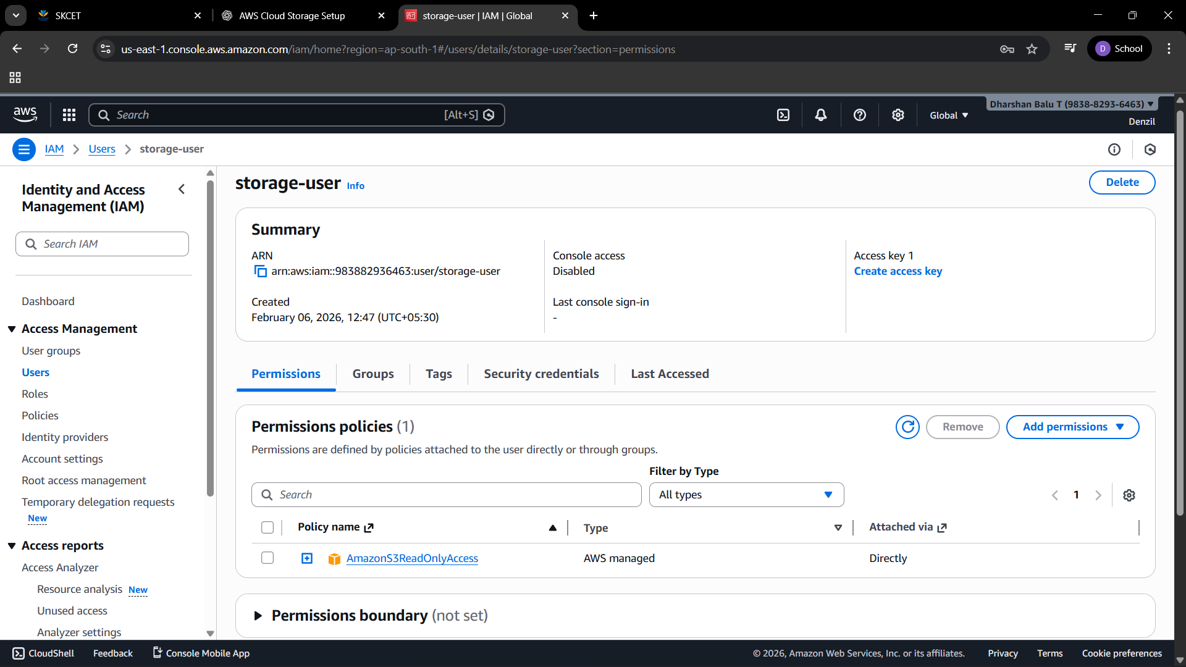

Step 5: Launch EC2 Instance
Action:
• Launch Amazon Linux 2 EC2 instance
• Instance type: t2.micro
Screenshot:
• EC2 instance running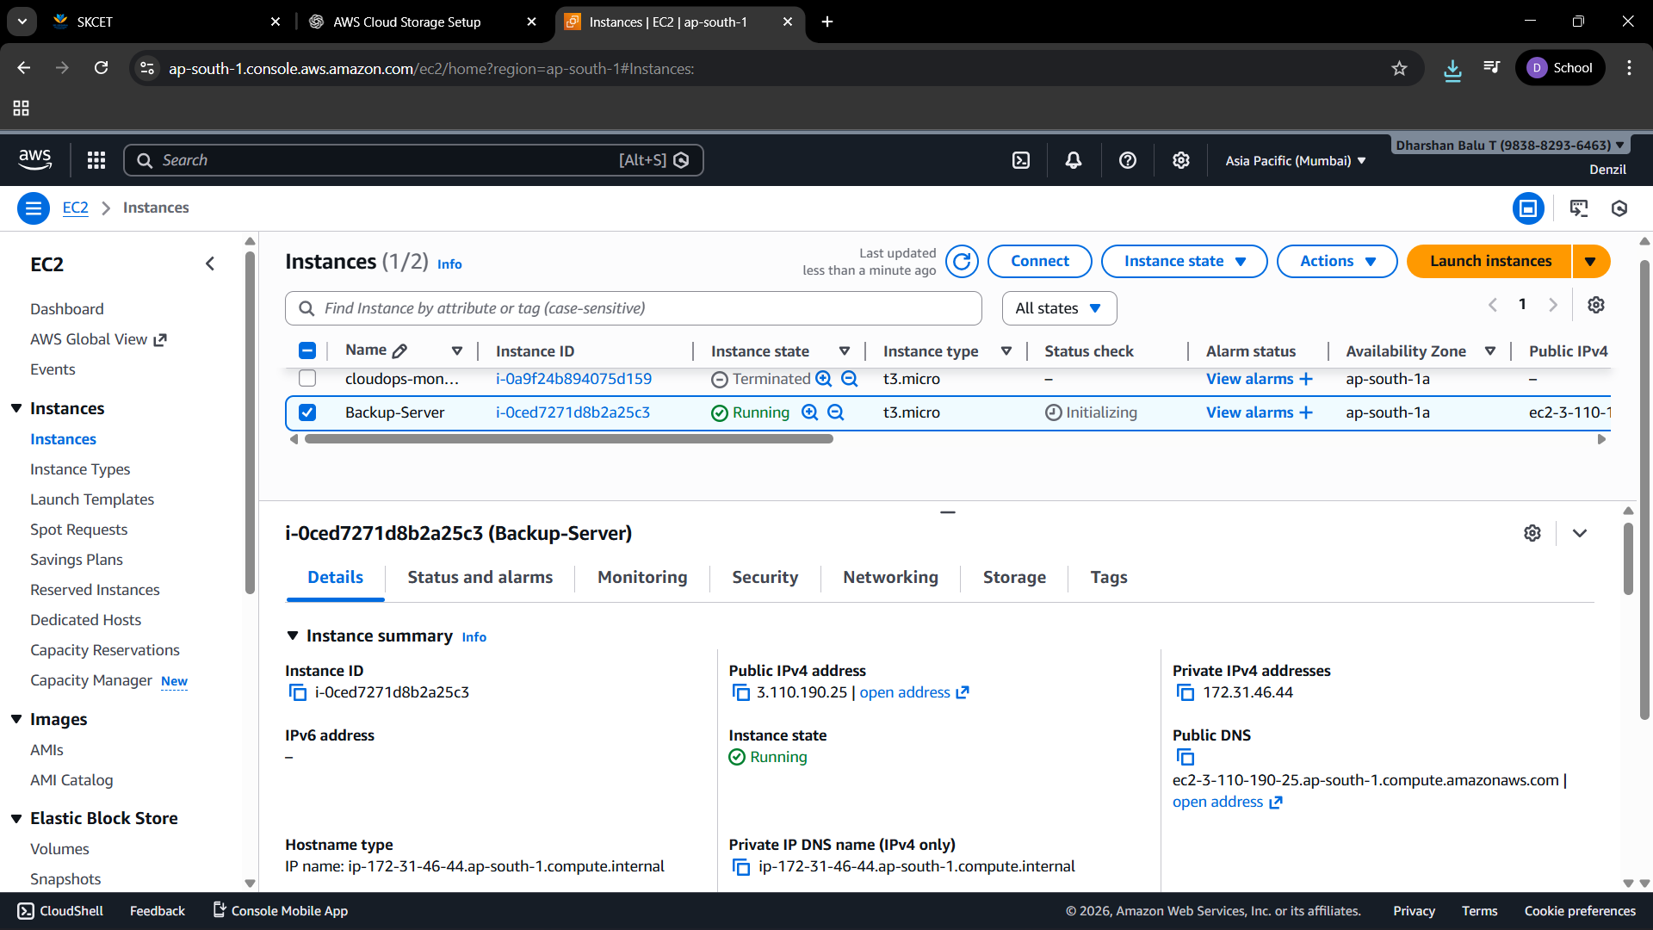

Step 6: Attach EBS Volume
Action:
• Create gp3 EBS volume
• Attach volume to EC2
Screenshot:
• EBS volume attached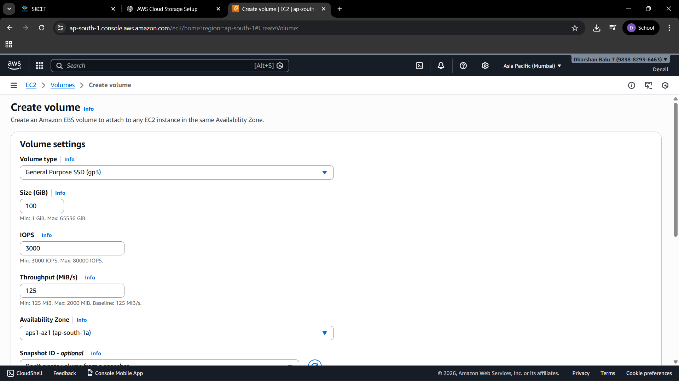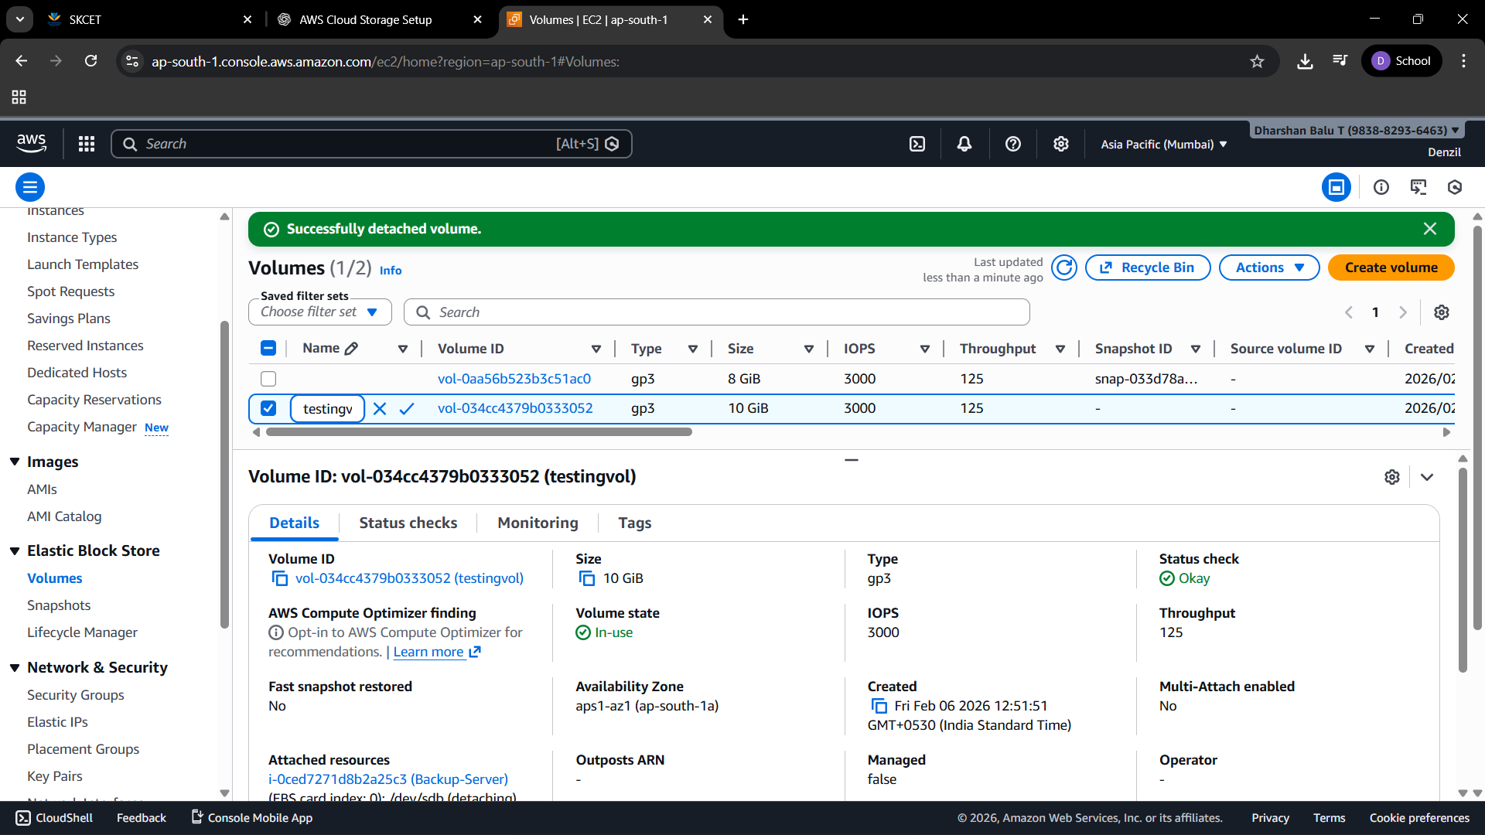

Step 7: Create Snapshot (Backup)
Action:
• Go to Volumes → Create Snapshot
Screenshot:
• Snapshot creation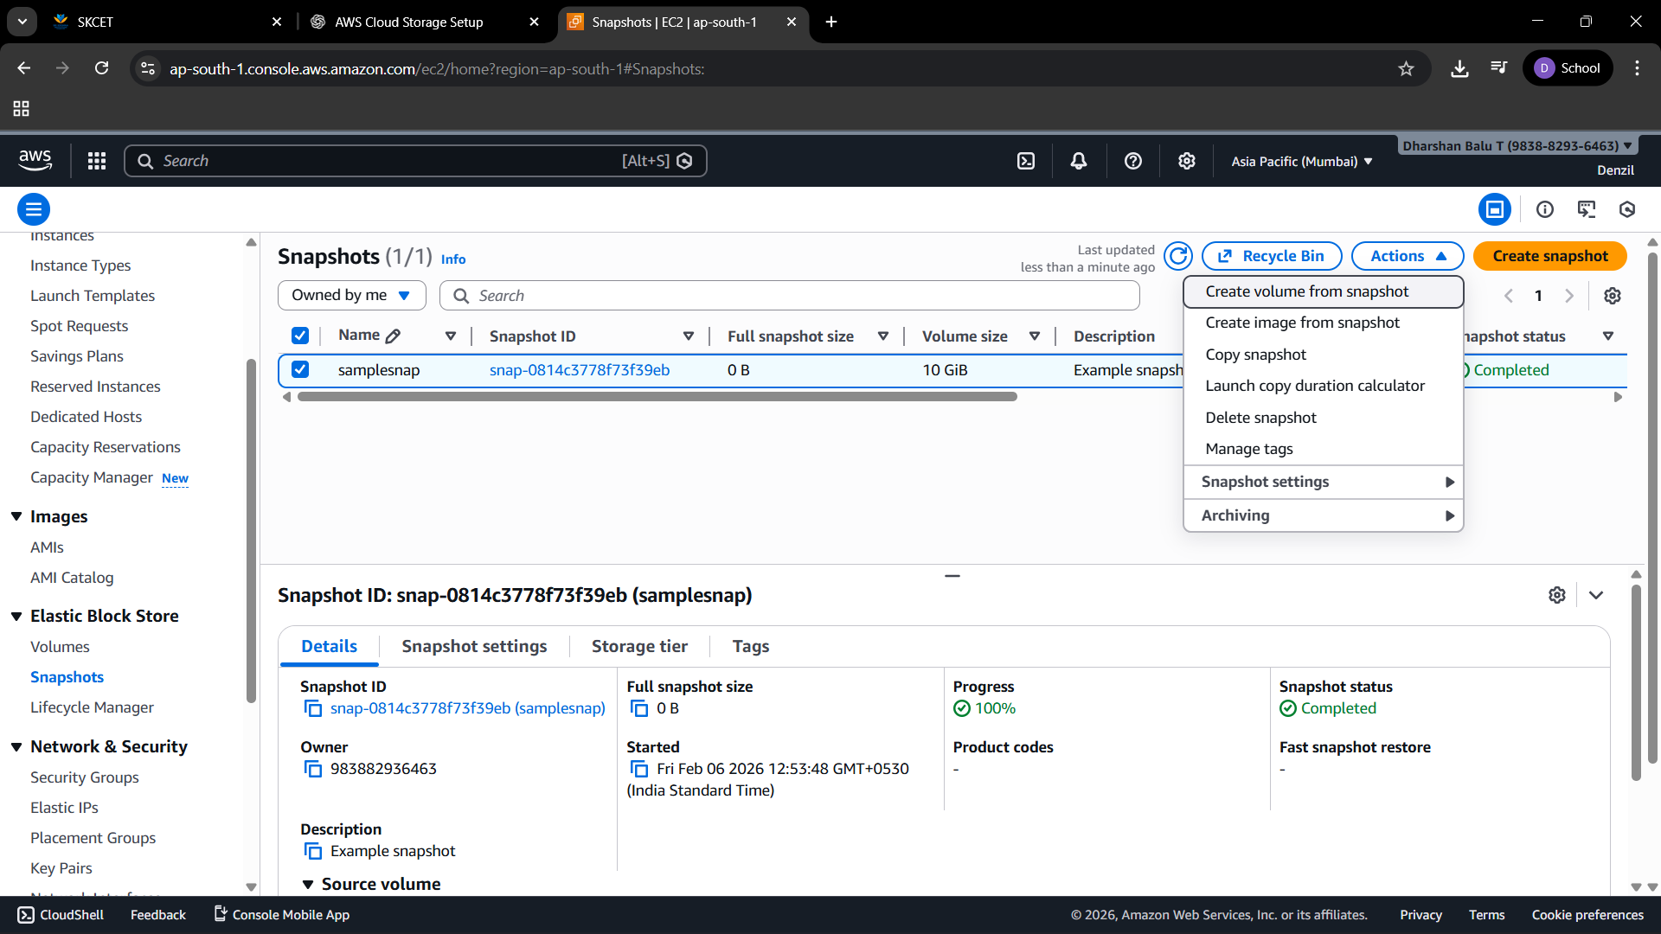
• Snapshot completed status

Step 8: Simulate Failure
Action:
• Detach EBS volume or delete files
Screenshot: • Volume detached or missing data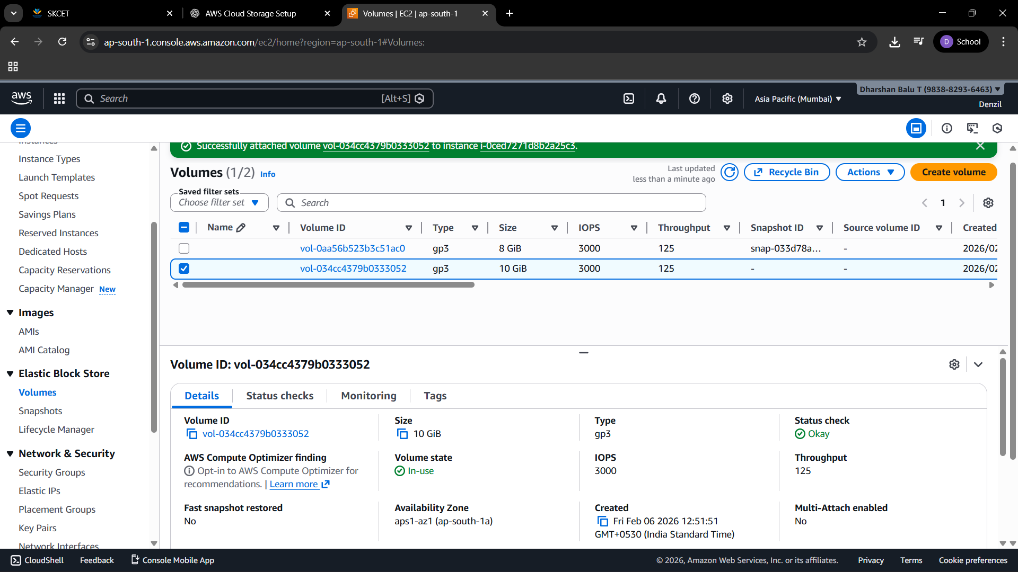

Step 9: Restore from Snapshot
Action:
• Create volume from snapshot
• Attach to EC2
Screenshot: • New volume attached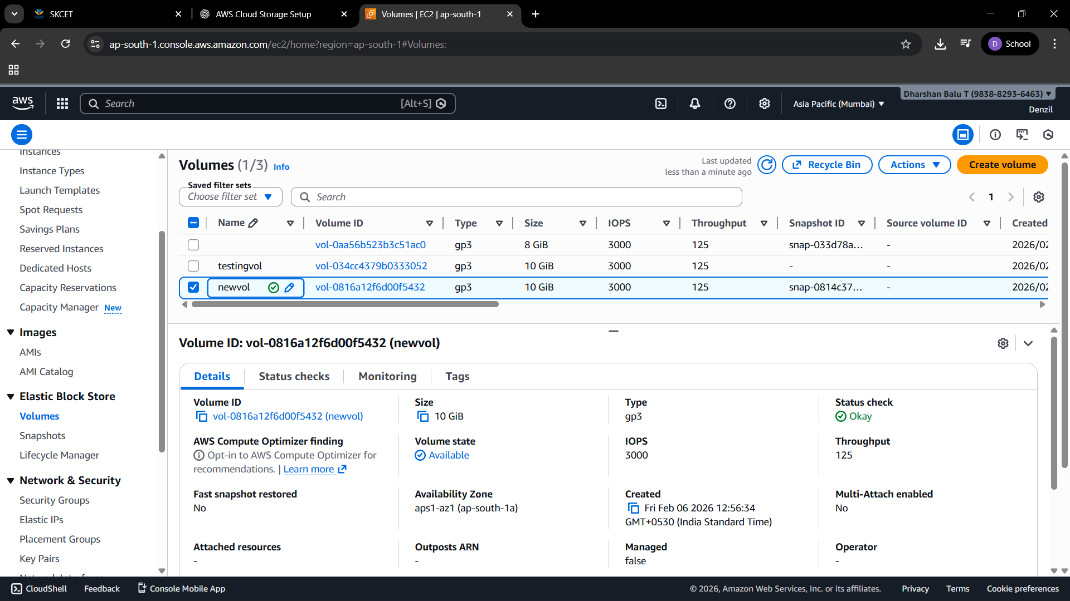

Step 10: Accidental Deletion Recovery (S3 Versioning)
Action:
• Delete a file from S3 bucket
• Enable 'Show versions'
• Delete the delete marker to restore file
Screenshot:
• File deletion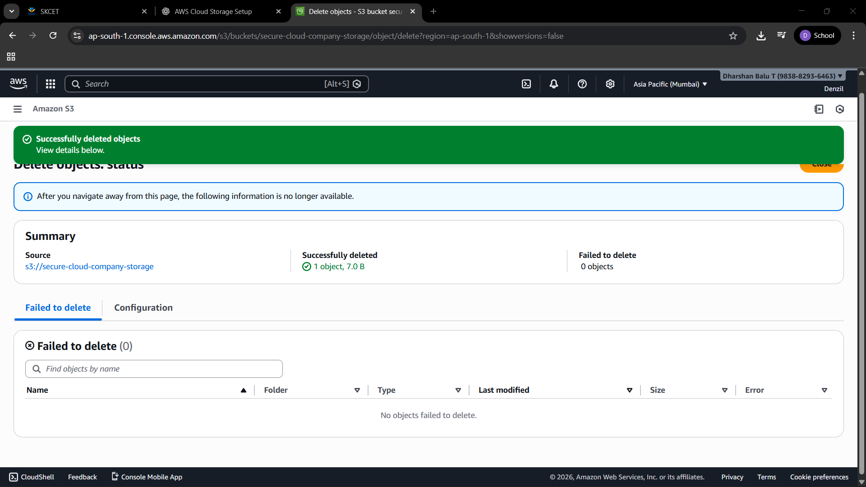
• Show versions enabled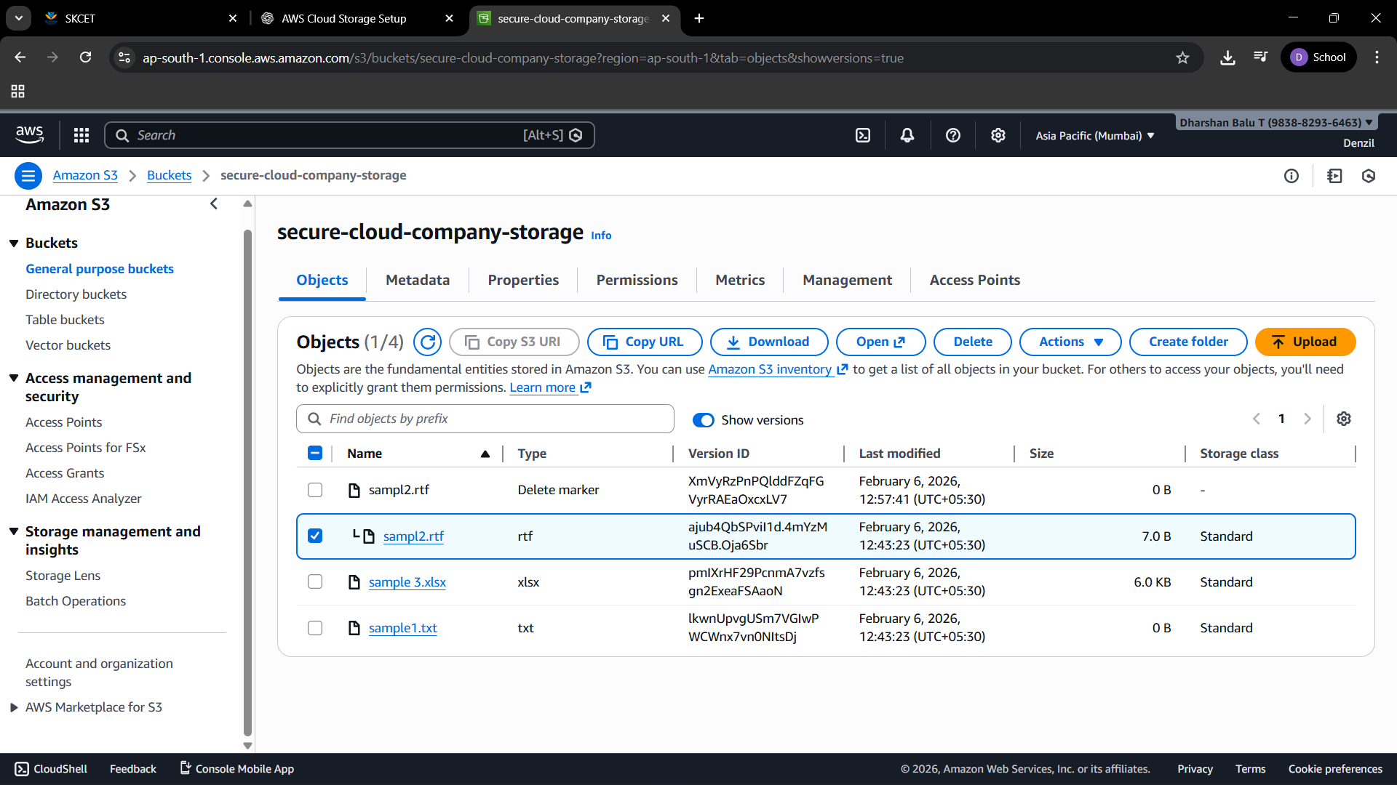
• Delete marker
• Restored file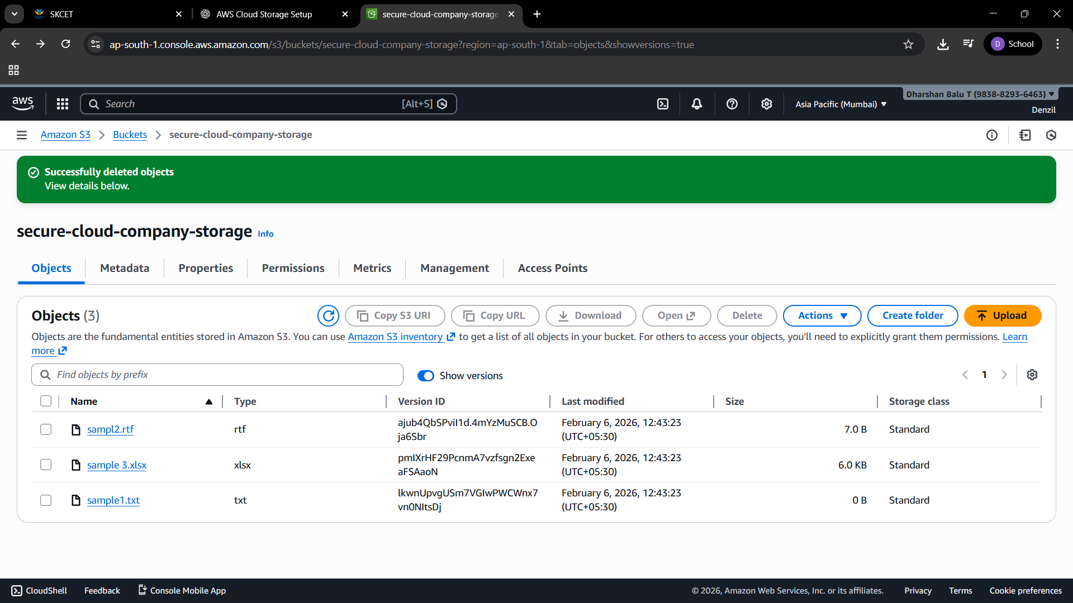

4. Security Measures
• Role-based access control using IAM
• Encryption at rest using SSE-S3
• Secure access using HTTPS

5. Performance Considerations
• gp3 EBS selected for predictable IOPS
• S3 provides high durability and availability

6. Conclusion
The project successfully demonstrates a secure cloud storage and backup solution. It protects against accidental deletion and disk failure while ensuring controlled access and data availability.

